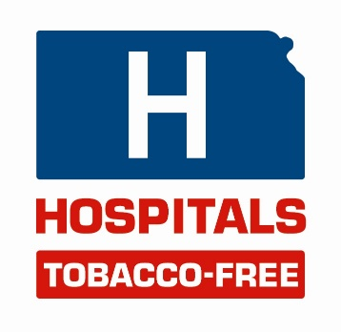
Sample Press Release

For Immediate Release
Contact – Hospital Spokesperson

Hospital Name Implements Tobacco-Free Campus Policy
(Date) Hospital Name is going tobacco-free on (date). As of that date, no tobacco use of any kind will be permitted – inside or outside – on hospital property. This initiative also will include the elimination of designated areas outside Hospital Name where employees, patients and visitors currently use tobacco products.

Hospital Name has joined hospitals across Kansas in an effort to become tobacco-free. As a health care organization, we are committed to the health and safety of our employees and patients. We believe that we have a responsibility to take a leadership role on this major health issue, and allowing people to use tobacco products defeats this purpose.

Tobacco is the cause of death for 4,400 Kansans every year and is the root cause of many illnesses
and lost productivity. Tobacco use in and around hospitals poses health and safety risks for patients, employees and visitors.

Hospital Name’s decision to go tobacco-free is not an attempt to “force” anyone to quit using tobacco products. Rather, the tobacco-free initiative is a concrete way we can demonstrate our ongoing commitment to healthy living.

We are asking for community support in Hospital Name’s tobacco-free initiative as we move toward (date).

# # #

