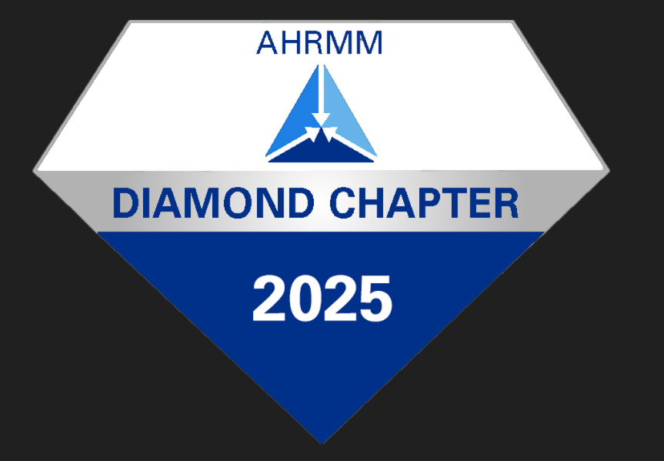
2026 KAHRMM Membership Form
Allied with the Kansas Hospital Association

Active, voting memberships are available to persons professionally engaged in Healthcare Supply Chain, Purchasing, Resource and/or Materials Management. Memberships available to GPO’s, as well as medical manufacturers, vendors, and distributors.
Memberships are also available to Healthcare professionals within other healthcare related settings not mentioned.

2026 KAHRMM Membership Categories (Please select one category)

_____ $100
_____ $ - 0 Contingent on having attended a 2025 KAHRMM Event, and submitting your 2026 Form before March 31st
_____ $ - 0 If you are a 2026 Newer Hospital or Non-Acute Healthcare Supply Chain Leader

Reminder: KAHRMM COMPLIMENTARY Memberships are contingent on last years (2025) Events Participation
- and having your 2026 KAHRMM Membership Form submitted prior to April 30, 2026.

Please check the appropriate selection:
_____ Renewal
_____ New Member

KAHRMM is a chapter affiliate of AHRMM, and recognized nationally by AHRMM as a Diamond chapter.
Making KAHRMM an awardee of AHRMM’s highest designation for over the last 15 years.

Are you a current member of AHRMM? Yes No If Yes, please add your AHRMM MBR# ________________

If you are not already a member of AHRMM, we encourage you to join on-line at the AHRMM website (www.AHRMM.org) as AHRMM offers additional networking and educational opportunities, as well as the Certified Materials & Resource Professional (CMRP), the premier certification for healthcare supply chain.

AHRMM FELLOW: Year Earned ____________ AHRMM CMRP: Year Earned ____________________________ __
Additional Certifications _____________________________________________________________________________

I hereby apply for membership in KAHRMM and certify that I meet the membership requirements of having attended at least ONE in-person meeting in 2025, and I plan to attend at least ONE in-person meeting in 2026.

Name (please print): _____________________________________________________________________
Title: __________________________________________________________________________________
Name of Hospital/ Employer: _______________________________________________________________
Street Address: __________________________________________________________________________
City: _________________________________ State: _______________ Zip Code: __________________
Work Phone: __________________________
Cell Phone: ___________________________
Email Address: __________________________________________________________________________
Hospital Employee: Yes Hospital Supplier: Yes
Applicant’s Signature: ____________________________________ Date Submitted: ___________

TOTAL KAHRMM MEMBERSHIP AMOUNT: $_________________ Submitted with your Membership Form
Please complete and email before 4-30-26 to KAHRMM President Mike Morgan at: michaelmorgan@mcphersonhospital.org

After 4/30, mail Form with payment to Attention of:
Chrissy Fink, RN and/ or email Chrissy at: cfink@mhsks.org
Heartland HealthCare Clinic
Abilene Kansas 67410

