2023 HVK Board of Directors and Executive Committee
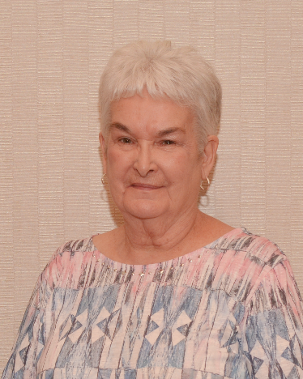 | 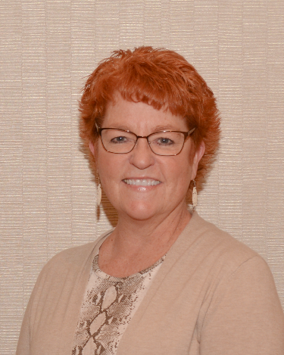 | 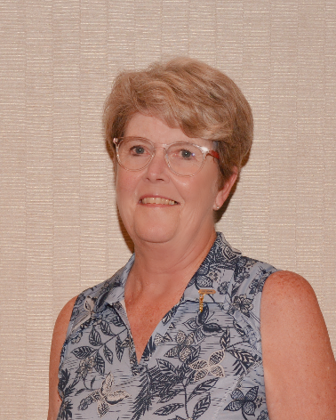
  PRESIDENT
  Sally Emerson
  615 W. 3rd Avenue
  Garnett, KS 66032
  Cell - 785-304-3217
  sallyemerson18@gmail.com
  Anderson County Hospital Auxiliary
  President Elect
  Shirley Van Loenen
  202 Holland Street
  Prairie View, KS 67664
  Home # 785-973-2252
  Cell # 785-973-8059
  shirleyvl@live.com
  svanloenen@phillipshospital.org
  Phillips Co. Hospital Volunteers
  TREASURER
  JoAnn Morse
  3100 Tam O'Shanter
  Hays, KS 67601
  Cell - 785-650-9852
  hvktreasurer@gmail.com
  HaysMed Volunteers
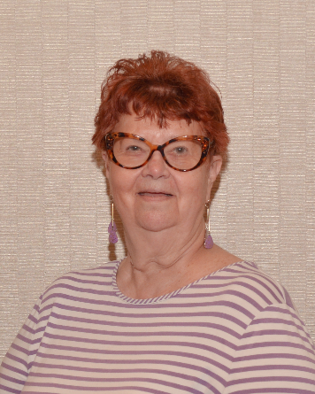 | 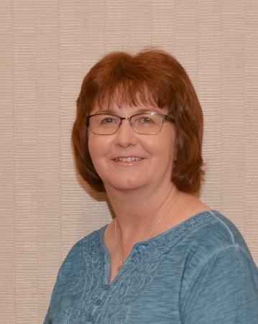 | 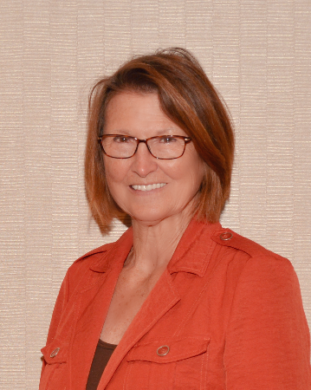
  Recording Secretary
  Jeannette Butler
  2042 Edward
  Salina, KS 67401
  Home - 785-826-9654
  Cell - 785-452-1774
  vjb3@cox.net
  Salina Regional Health Center
  MEMBERSHIP SECRETARY
  Debi Rempe
  411 E. 20th St.
  Hays, KS 67601
  Cell - 785-628-2471
  HVKmembersec@gmail.com
  HaysMed Volunteers
  PAST PRESIDENT
  Peggy Ogle
  9385 1000 Road
  Fredonia, KS 66736
  Cell - 620-288-0918
  peggyogle49@gmail.com
  Fredonia Regional Hospital Vol.
2023 HVK District Coordinators

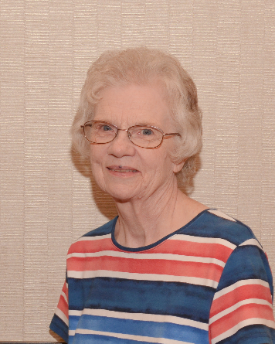 | 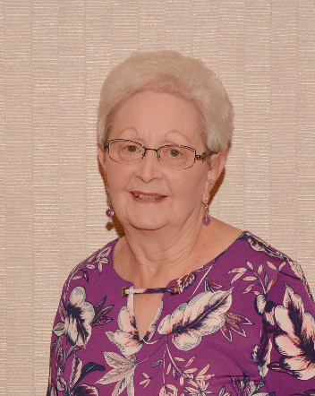 | 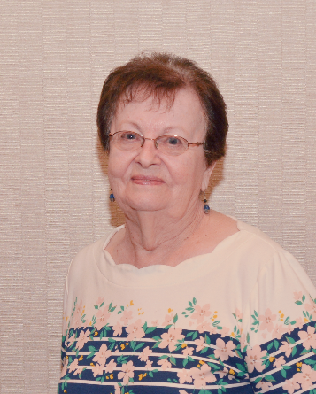
  DISTRICT ONE COORDINATOR
  Carol Bauck
  1117 South Maple
  Ottawa, KS 66067
  Home – 785-242-5653
  Cell – 785-893-2997
  mcbauck@att.net
  Advent Health Ottawa Aux.
  DISTRICT TWO COORDINATOR
  Nancy Horn
  1322 S. Walnut
  Garnett, KS 66032
  Home – 785-448-6544
  Cell – 785-304-2675
  66ricna@gmail.com
  Anderson Co. Hospital Auxiliary
  DISTRICT THREE COORDINATOR
  Jean Buoy
  P.O. Box 383
  Concordia, KS 66901
  785-243-6295
  JJBuoy@sbcglobal.net
  Cloud Co. Health Center Aux.
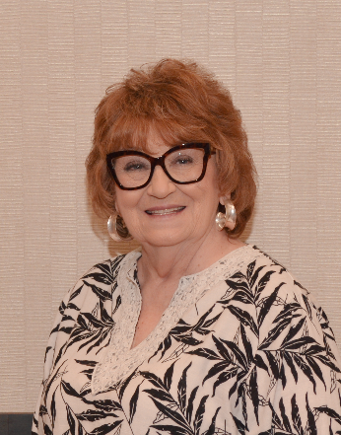 | 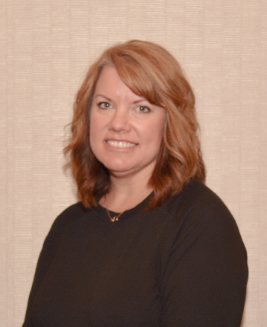 | 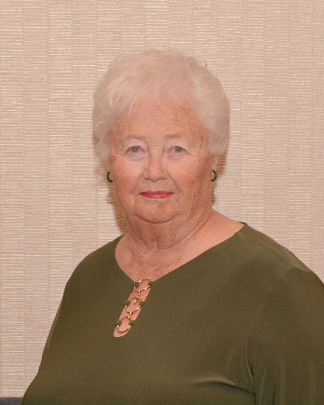
  DISTRICT FOUR COORDINATOR
  Judie Ellis
  1947 N. Marlin Ct
  Andover, KS 67002
  Cell – 316-519-5495
  jade042@att.net
  Via Christi Vol. Partners in Caring
  DISTRICT FIVE COORDINATOR
  Nikki Mihm
  2220 Canterbury
  Hays, KS 67601
  Cell – 785-639-1934
  nmihm@haysmed.com
  HaysMed Volunteers
  DISTRICT SIX COORDINATOR
  Barbara Hammond
  903 Toles Avenue
  Larned, KS 67550
  Cell – 620-285-1787
  barbarah5502@att.net
  Pawnee Valley Com. Hosp. Aux.

Special Appointments

  Member At-Large
  Convention Co-Chairperson
  Connie Carlton
  1208 4th Terrace Drive
  Larned, KS 67550
  Cell – 620-285-9216
  csclarkan@gmail.com
  Pawnee Valley Comm. Hospital
  Member At-Large
  Convention Co-Chairperson
  Norman Tice
  6020 E. 8th St. North
  Wichita, KS 67208
  Home – 316-524-0995
  Cell – 316-719-0784
  ticenorman166@gmail.com
  Sunflower Editor
  Convention Co-Chairperson
  Diana Holloway
  536 Oak Lane
  McPherson, KS 67460
  620-242-8296
  dianaholloway@mcphersonhospital.org
  McPherson Hospital Vol. Serv.
  Convention Chairperson
  Rose Stroud
  2525 N. Beacon Hill St.
  Wichita, KS 67220
  Cell – 316-993-2467
  RJStroud669@gmail.com
  Wesley Medical Center Auxiliary
  Parliamentarian
  Floyd Joliet
  410 N. 160th Street
  Girard, KS 66743
  Home – 620-724-8179
  Cell – 620-238-6893
  Girard Medical Center Auxiliary
  Counselor/Nominating Chairperson
  Peggy Ogle
  9385 1000 Road
  Fredonia, KS 66736
  Cell – 620-288-0918
  peggyogle49@gmail.com
  Fredonia Reg. Hospital Auxiliary
  Legislative
  Rose Stroud
  2525 N. Beacon Hill St.
  Wichita, KS 67220
  Cell – 316-993-2467
  RJStroud669@gmail.com
  Wesley Medical Center Auxiliary
  KHA Liaison
  Amy Fluke
  215 SE 8th Street
  Topeka, KS 66603
  Work - 785-233-7436 Ext. 129
  afluke@kha-net.org
  KHA Office

